**Chapter-01**

**INTRODUCTION**

**1.1 OVERVIEW**

Alzheimer's disease is a progressive neurodegenerative disorder characterized by cognitive decline, memory loss, and behavioral changes. Early detection of Alzheimer's is crucial for timely intervention and improved patient outcomes. This project explores a hybrid approach leveraging machine learning (ML) techniques alongside cognitive testing to enhance the accuracy and efficiency of Alzheimer's diagnosis.

**1.2 ALZHEIMER'S DISEASE**

**1.2.1 About Alzheimer's**

Alzheimer's disease stands as the preeminent form of dementia, encompassing a substantial majority of dementia cases, ranging from 60% to 80% of all instances. It principally afflicts older individuals, although there exist occurrences of early-onset cases that diverge from this general trend. The pathology of this disease is marked by profound disturbances in the normal operation of the brain, which precipitate the progressive degeneration of cognitive faculties encompassing memory, cognition, and behavioral patterns.

The etiology of Alzheimer's remains a subject of considerable scientific inquiry and continues to pose challenges to elucidate fully. Genetic predispositions, lifestyle factors, and environmental influences interplay in multifaceted ways to confer susceptibility to this condition. Key pathological hallmarks of Alzheimer's encompass the accumulation of neurofibrillary tangles and amyloid plaques within the brain, culminating in the progressive loss of neuronal function and structural integrity.

Clinical manifestations of Alzheimer's disease are diverse and encompass a spectrum of cognitive and behavioral disturbances. The cardinal symptoms prominently feature deficits in memory consolidation and recall, impairments in executive function, and disruptions in language and spatial awareness. Behavioral changes, including agitation, apathy, and mood fluctuations, frequently accompany the cognitive decline observed in affected individuals.

The course of Alzheimer's disease is insidious and inexorable, characterized by a gradual onset and progressive deterioration of cognitive abilities over time. The disease trajectory varies widely among affected individuals, ranging from a protracted decline spanning several years to more rapid cognitive decline in some cases. As the disease advances, individuals often necessitate increasing levels of support and care to manage the complex array of symptoms and functional impairments.

Notably, the societal and economic impact of Alzheimer's disease is profound, exerting substantial burdens on healthcare systems, families, and caregivers. The escalating prevalence of this condition within aging populations underscores the urgent imperative for innovative approaches to diagnosis, treatment, and care.

Alzheimer's disease represents a formidable neurodegenerative disorder characterized by its prevalence, complexity, and profound impact on individuals and society at large. Efforts to comprehend the intricate interplay of genetic and environmental factors underlying disease pathogenesis are pivotal for advancing therapeutic interventions and preventive strategies.

**1.2.2 Statistics of the Disease**

Alzheimer's disease presents a formidable global health challenge, with a vast number of individuals affected worldwide. Current estimates suggest that at least 44 million people are living with dementia, a significant proportion of which is attributed to Alzheimer's disease. Projections indicate a startling increase, with expectations that the number of dementia cases will surge to 139 million by the year 2050 as depicted in **Figure 1.1,** underscoring the urgency of addressing this escalating public health issue.

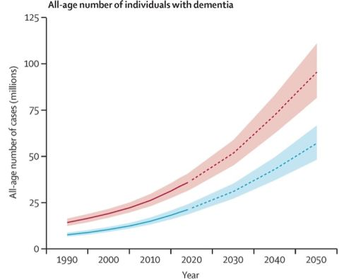Age emerges as the primary determinant of Alzheimer's risk, with most diagnosed cases occurring in individuals aged 65 and older. Nevertheless, early-onset Alzheimer's, impacting individuals younger than 65, although less prevalent, represents a distinct subset of affected individuals.

**Figure 1.1 Alzheimer Case Graph**

Regional disparities in Alzheimer's prevalence are noteworthy, with high-income nations typically reporting higher rates due to enhanced diagnostic capabilities and longer life expectancies. Conversely, low- and middle-income countries anticipate the most rapid growth in Alzheimer's cases due to shifting demographics and increased longevity.

India, as a case study, presents intriguing insights into the epidemiology of Alzheimer's disease. Despite the staggering global burden, India reports a seemingly lower prevalence, estimated at over 4 million individuals affected by dementia, with Alzheimer's contributing significantly to this figure. The estimated prevalence rate of Alzheimer's and related dementias in India stands at approximately 4.3%.

Several factors may contribute to the apparent lower rates of Alzheimer's disease observed in India compared to developed nations. Traditional dietary practices in India, rich in turmeric containing curcumin, are posited to possess neuroprotective properties, potentially mitigating cognitive decline. Additionally, robust social and familial support systems prevalent in Indian society may afford cognitive stimulation and delay the onset of dementia symptoms.

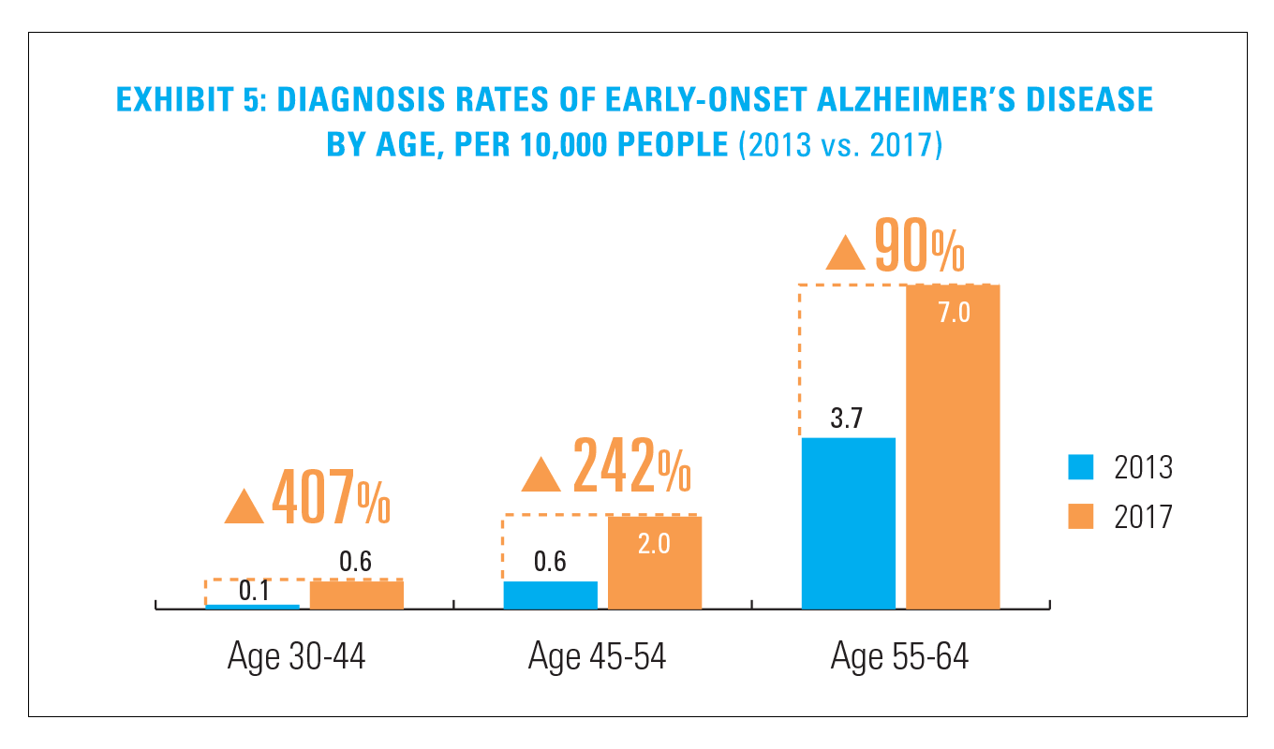Socioeconomic factors, including limited access to healthcare facilities and pervasive social stigma surrounding dementia, likely contribute to underdiagnosis, particularly in rural regions. Furthermore, historical trends in life expectancy and healthcare infrastructure might have influenced the detection and reporting of Alzheimer's cases in India, suggesting that reported figures may underestimate the true prevalence.

**Figure 1.2 Alzheimer's representation by Age**

Efforts to accurately assess the burden of Alzheimer's disease in India remain ongoing, necessitating further research to elucidate the complex interplay of genetic, environmental, and sociocultural factors influencing disease prevalence. Enhanced awareness campaigns, improved healthcare infrastructure, and expanded research initiatives are imperative to address the growing challenge of Alzheimer's disease in India and globally represented in **Figure 1.2**.

**1.2.3 Effects**

The effects of Alzheimer's disease manifest as a profound and multifaceted decline in cognitive and behavioral faculties, exerting a profound impact on affected individuals and their caregivers. This neurodegenerative condition precipitates a cascade of symptoms that progressively erode autonomy and quality of life.

* **Cognitive Impairment:** Alzheimer's disease initiates with subtle changes in memory, manifesting as short-term memory lapses and difficulty recalling recent events. As the disease advances, individuals encounter pronounced memory deficits, struggling to recognize familiar faces, places, and even themselves. Semantic memory, encompassing general knowledge and language comprehension, also deteriorates, impairing communication and comprehension abilities.
* **Executive Dysfunction:** Alzheimer's disrupts executive functions critical for planning, organizing, and problem-solving. Individuals may struggle with tasks requiring attention, decision-making, and reasoning. Complex activities like managing finances or following instructions become increasingly challenging and eventually insurmountable.
* **Visuospatial Skills:** Spatial orientation and perception are compromised as Alzheimer's progresses. Individuals experience difficulties navigating familiar environments, judging distances, and recognizing objects. Visual agnosia, the inability to identify objects or faces by sight, may cause further complicated daily interactions.
* **Language Deficits:** Alzheimer's erodes language abilities, impairing both comprehension and expression. Vocabulary becomes limited, and individuals may struggle to find words or maintain coherent conversations. Writing and reading skills deteriorate, impeding communication and exacerbating social isolation.
* **Behavioral Changes:** Alzheimer's often precipitates alterations in behavior and personality. Individuals may exhibit mood swings, agitation, or apathy. Anxiety and depression are common comorbidities, exacerbating emotional distress and caregiver burden.
* **Functional Decline:** Basic activities of daily living progressively erode as Alzheimer's advances. Individuals struggle with self-care tasks such as bathing, dressing, and feeding. Motor coordination diminishes, leading to difficulties with mobility and coordination.
* **Psychological Distress:** The cognitive decline inherent in Alzheimer's engenders profound psychological distress for affected individuals. Awareness of declining abilities may evoke fear, frustration, and feelings of helplessness. Delusions and hallucinations can further exacerbate emotional turmoil.
* **Loss of Independence:** As Alzheimer's disease robs individuals of cognitive and functional capacities, independence is gradually relinquished. Dependence on caregivers for essential tasks intensifies, culminating in a loss of autonomy and self-identity.
* **Impact on Caregivers:** The repercussions of Alzheimer's extend beyond the individual to encompass caregivers and family members. Caregivers shoulder significant emotional, physical, and financial burdens, navigating the challenges of providing continuous care and support.
* **Social Isolation:** Alzheimer's disease precipitates social withdrawal as communication abilities deteriorates and behavioral changes emerge. Individuals may retreat from social interactions due to embarrassment or confusion, leading to isolation and loneliness.

**1.2.4 Causes**

The etiology of Alzheimer's disease is the subject of intricate investigation, characterized by multifaceted interactions between genetic predispositions, environmental factors, and age-related processes. While the precise causative mechanisms remain elusive, researchers have identified several contributory factors implicated in the pathogenesis of this neurodegenerative disorder.

* **Genetic Susceptibility:** Genetic factors play a pivotal role in predisposing individuals to Alzheimer's disease. Variations in genes encoding proteins involved in amyloid metabolism, such as APP (Amyloid Precursor Protein), PSEN1 (Presenilin 1), and PSEN2 (Presenilin 2), have been linked to familial forms of the disease. Inherited mutations in these genes disrupt amyloid processing, leading to the accumulation of amyloid-beta plaques characteristic of Alzheimer's pathology.
* **Apoptotic Pathways:** Dysregulation of apoptotic pathways within neurons contributes to neuronal death observed in Alzheimer's disease. Aberrant activation of caspases, a family of proteases implicated in programmed cell death, leads to neurodegeneration and synaptic dysfunction. Mitochondrial dysfunction and oxidative stress further exacerbate apoptotic signaling cascades, accelerating neuronal demise.
* **Neuroinflammation:** Chronic neuroinflammation represents a key pathological feature of Alzheimer's disease. Activation of microglia, the brain's resident immune cells, in response to amyloid deposition triggers the release of pro-inflammatory cytokines and reactive oxygen species. Prolonged neuroinflammatory responses culminate in synaptic dysfunction and neuronal injury, contributing to disease progression.
* **Vascular Factors:** Vascular abnormalities and cerebral hypoperfusion contribute to the pathogenesis of Alzheimer's disease, particularly in cases of mixed dementia. Reduced blood flow compromises nutrient and oxygen delivery to brain tissues, exacerbating neuronal vulnerability and promoting the accumulation of neurotoxic proteins.
* **Tau Protein Dysregulation:** The hyperphosphorylation and aggregation of tau protein into neurofibrillary tangles represents critical events in Alzheimer's pathogenesis. Tau pathology disrupts microtubule stability, impairing axonal transport and synaptic function. Tau-mediated neurotoxicity exacerbates neuronal degeneration and cognitive decline in affected individuals.
* **Environmental Exposures:** Environmental factors, including lifestyle choices and exposure to toxins, may modulate Alzheimer's risk. Chronic exposure to air pollution, heavy metals, or pesticides has been associated with increased neuroinflammation and oxidative stress, predisposing individuals to neurodegenerative disorders.
* **Aging and Cellular Senescence:** Aging represents the primary risk factor for Alzheimer's disease. Age-related changes in cellular homeostasis, including mitochondrial dysfunction, telomere shortening, and impaired DNA repair mechanisms, contribute to neuronal vulnerability and cognitive decline observed in aging populations.
* **Epigenetic Modifications:** Epigenetic alterations, encompassing changes in DNA methylation, histone modifications, and non-coding RNA expression, influence gene regulation in Alzheimer's disease. Dysregulated epigenetic mechanisms contribute to aberrant gene expression profiles implicated in disease pathogenesis and progression.

**1.2.5 Treatment**

The treatment landscape for Alzheimer's disease encompasses a range of pharmacological and non-pharmacological interventions aimed at ameliorating symptoms, delaying disease progression, and enhancing quality of life for affected individuals. While there is currently no cure for Alzheimer's, therapeutic approaches focus on addressing specific aspects of the disease pathology and associated cognitive deficits. One cornerstone of pharmacological intervention involves the use of cholinesterase inhibitors, such as donepezil, rivastigmine, and galantamine, which augment cholinergic neurotransmission in the brain. By inhibiting the breakdown of acetylcholine, a key neurotransmitter involved in memory and cognition, these medications help alleviate cognitive symptoms and enhance cognitive function to some degree.

Another class of medications used in Alzheimer's treatment targets glutamatergic neurotransmission. Memantine, an NMDA receptor antagonist, modulates glutamate signaling to prevent excitotoxicity and neuronal damage. Memantine is typically prescribed in moderate to severe cases of Alzheimer's to manage symptoms and improve cognitive stability. Beyond pharmacotherapy, non-pharmacological interventions play a critical role in Alzheimer's management. Cognitive stimulation therapies, including reminiscence therapy, reality orientation, and cognitive training, aim to engage cognitive functions and promote neural plasticity. These interventions may help preserve cognitive abilities and enhance overall well-being in affected individuals. Behavioral and psychological interventions, such as cognitive behavioral therapy (CBT) and caregiver education and support, address behavioral symptoms associated with Alzheimer's disease. CBT techniques target maladaptive behaviors and cognitive distortions, fostering adaptive coping strategies and improving emotional regulation.

In recent years, lifestyle modifications have gained attention as potential adjunctive therapies for Alzheimer's disease. Regular physical exercise, a balanced diet rich in antioxidants and omega-3 fatty acids, and social engagement have been shown to mitigate cognitive decline and promote brain health. Physical activity promotes neurogenesis and synaptic plasticity, while dietary interventions reduce oxidative stress and inflammation, mitigating neuronal damage.

Emerging therapeutic modalities on the horizon include immunotherapies targeting amyloid-beta and tau proteins, which constitute the pathological hallmarks of Alzheimer's disease. Monoclonal antibodies and vaccines designed to clear amyloid plaques and tau tangles from the brain represent promising avenues for disease-modifying treatments.

**1.3 Role of Technology in Diagnosing Alzheimer's**

The integration of advanced technology, particularly machine learning (ML) techniques, holds significant promise in revolutionizing the diagnosis and assessment of Alzheimer's disease. This innovative project harnesses the power of convolutional neural networks (CNNs) and employs sophisticated transfer learning methods to analyze magnetic resonance imaging (MRI) scans. These MRI images are meticulously scrutinized and classified based on distinct categories delineating the severity of dementia.

Specifically, the utilization of convolutional neural networks (CNNs) represents a cutting-edge approach within the realm of artificial intelligence (AI) and machine learning. CNNs are adept at extracting intricate and nuanced features from complex medical images, such as MRI scans of the brain. This capability enables the identification of subtle patterns and anomalies that may signify the onset or progression of Alzheimer's disease.

Furthermore, transfer learning techniques are instrumental in enhancing the performance and accuracy of machine learning models, such as the InceptionV3 architecture utilized in this project. Transfer learning leverages pre-existing knowledge and expertise encoded within one neural network to expedite and optimize the learning process of another network. By leveraging insights gleaned from a trained CNN model, the InceptionV3 model is primed to discern and classify MRI images based on varying degrees of dementia severity.

In parallel with machine learning methodologies, cognitive testing represents a cornerstone in the diagnostic toolkit for Alzheimer's disease. The Mini-Mental State Examination (MMSE) exemplifies a standardized cognitive assessment tool utilized to evaluate and quantify impairments across various cognitive domains. The MMSE encompasses a battery of tasks encompassing memory recall, spatial orientation, language comprehension, and executive function. By systematically assessing cognitive abilities, the MMSE furnishes clinicians with invaluable insights into the nature and extent of cognitive impairment characteristic of Alzheimer's disease.

The synergy between machine learning technologies and traditional cognitive assessments epitomizes a hybrid approach that capitalizes on the strengths of both methodologies. While machine learning algorithms excel in discerning subtle patterns within voluminous datasets, cognitive assessments like the MMSE offer nuanced insights into the functional and behavioral manifestations of Alzheimer's disease.

The intersection of technology and cognitive science underscores the transformative potential of interdisciplinary collaboration in the domain of Alzheimer's diagnosis. By amalgamating state-of-the-art machine learning techniques with validated cognitive assessments, this project endeavors to enhance diagnostic accuracy, facilitate early intervention, and ultimately improve patient outcomes within the context of Alzheimer's disease.

**1.4 Hybrid Approach: Integrating Machine Learning and Cognitive Testing**

The fusion of machine learning methodologies with cognitive testing signifies a pioneering hybrid approach that amalgamates the inherent advantages of both disciplines. This innovative integration harnesses sophisticated algorithms to scrutinize complex MRI data in tandem with traditional cognitive assessments, culminating in a synergistic diagnostic framework tailored to enhance accuracy and expedite the detection of Alzheimer's disease.

Machine learning techniques, epitomized by convolutional neural networks (CNNs) and transfer learning, offer unparalleled capabilities in processing and analyzing intricate MRI images of the brain. By leveraging advanced algorithms, these methodologies discern subtle patterns and anomalies within voluminous datasets, thereby facilitating the classification and stratification of dementia severity with enhanced precision.

Concomitantly, cognitive testing, exemplified by the Mini-Mental State Examination (MMSE) and analogous assessments, provides a comprehensive evaluation of cognitive faculties encompassing memory, orientation, language, and executive function. This traditional approach furnishes clinicians with valuable insights into cognitive impairment, complementing the quantitative analyses derived from machine learning algorithms.

The integration of these complementary methodologies empowers clinicians and researchers to capitalize on the strengths of both disciplines, thereby augmenting diagnostic capabilities and elucidating nuanced aspects of Alzheimer's disease pathology. By synergistically leveraging sophisticated technology and validated cognitive assessments, this hybrid approach represents a paradigm shift in Alzheimer's diagnosis, heralding a new era of precision medicine tailored to individual patient profiles.

**Chapter – 02**

**PROBLEM STATEMENT**

In the realm of Alzheimer's disease prediction, the integration of advanced computational techniques, including deep learning, offers a transformative opportunity to enhance diagnostic accuracy and facilitate early intervention. Our project aims to harness these methodologies to develop a robust system for Alzheimer's prediction, leveraging neuroimaging data and cognitive assessments such as the Mini-Mental State Examination (MMSE).

*“To create a reliable system that accurately classifies individuals with Alzheimer's disease or as non-demented using brain MRI images from diverse clinical datasets. This involves employing an advanced CNN model with transfer learning techniques and integrating cognitive testing for a comprehensive diagnostic approach.”*

The specific objectives of our project are as follows:

1. **Understanding and Analyzing Neuroimaging Data:** Our primary objective is to comprehensively analyze neuroimaging data, particularly MRI scans, to extract meaningful insights about brain structure and potential biomarkers associated with Alzheimer's disease.
2. **Building a Deep Learning Model:** We endeavor to construct a sophisticated deep learning model, utilizing advanced architectures like convolutional neural networks (CNNs) or recurrent neural networks (RNNs), to analyze neuroimaging data alongside patient demographics and MMSE scores. This model will be trained to classify individuals into distinct categories based on Alzheimer's disease status (e.g., Alzheimer's vs. normal), integrating cognitive assessments for enhanced diagnostic accuracy.
3. **Incorporating MMSE Scores**: An integral aspect of our project involves incorporating MMSE scores as a critical feature in our deep learning model. MMSE assessments provide valuable insights into cognitive impairment and will serve as an additional input for Alzheimer's prediction alongside neuroimaging data.
4. **Development of Evaluation Metrics:** We will establish a comprehensive evaluation framework using summary data derived from neuroimaging analyses and MMSE assessments. This framework will enable cross-verification and validation of the deep learning model's predictive performance, ensuring robustness and reliability.

**Chapter – 03**

**LITERATURE SURVEY**

**3.1 M Sai Teja, K Thanuja, Nadella Mani Deep, P Ravindra Reddy, & O Likhith Kumar Reddy. (2023) [1]** in this paper offers a new way of Prediction model to predict AD in patients. In this project we have successfully classified the images of MRI images of a person, Mild Demented, Moderate Demented, Nondemented, Very Mild Demented using the deep learning algorithms. Here, we have considered the dataset of MRI images which will be of 4 different types and trained using Modified CNN. VGG16 algorithms. After the training we tested by uploading the image and classified it.

The technologies used are CNN, VG 16 and Alex-Net

The limitations are as follows: Computational Cost of VGG16: VGG16, with its 16 layers, can be computationally expensive and memory-intensive, limiting its practicality in resource-constrained environments.

**3.2 Oh, K., Chung, YC., Kim, K.W. et al [2]** in this paper Thes paper presents a deep learning approach for the classification and visualization of Alzheimer's disease using MRI data. The authors propose an end-to-end learning method for four binary classification tasks based on volumetric convolutional neural networks. They also use a gradient-based visualization technique to identify important biomarkers related to Alzheimer's disease and mild cognitive impairment.

The technology used are CNN, SVM (Support Vector Machines), RBM (Restricted Boltzmann Machine), DBN (Deep Belief Network)

The limitations are as follows: Human Intervention Exclusion: While the study highlights the visualization of CNN outcomes without human intervention, it may overlook the importance of human expertise in validating and interpreting results, especially in medical contexts.

**3.3 Ayisha Shamna. K K, Jamsheera. K, Shameena. P P [3]** in this paper discusses a two-stage task-oriented deep learning method for anatomical landmark detection and Alzheimer's disease diagnosis using limited medical imaging data. The method uses two neural networks, local and global operations, to detect landmark points. HOG and longitudinal features are extracted from the landmark points and used with SVM to diagnose Alzheimer's disease. which shows the landmark point detection and the analysis of HOG and longitudinal features. The features are concatenated and used to train SVM for classification tasks.

The technology used is SVM and CNN.

The limitations are as follows Limited Training Data Challenge: The study acknowledges the challenge of limited training data, which can adversely affect the performance of deep learning models. Deep learning models, especially CNNs, often require large amounts of labeled data for effective training, and a scarcity of data can lead to overfitting and reduced generalization.

**3.4 Raees, P & Thomas, Vinu. (2021) [4]** in this paper the disease causes a progressive mental deterioration due to brain degeneration, ultimately leading to death. It is the cause of around 60-70% of dementia cases and affects millions of people globally. Early diagnosis is essential for better clinical, social, and economic outcomes. Deep learning algorithms offer high accuracy of 80-90% in predicting AD, with Support Vector Machines and different models of DNN algorithms tested. Applying highly accurate computational tools will help diagnose the disease in its early stages. There are medical treatments in the early stages, but the progression of AD is irreversible. The number of people suffering from AD is expected to triple by 2050.

The technology used are Alex-Net, VGG-16, ResNet-50

The limitations are as follows: Computational Intensity: Deep learning, especially when utilizing GPU acceleration, demands significant computational resources, limiting accessibility for researchers with constrained hardware.

**3.5. Kavitha C., Mani Vinodhini, Srividhya S. R., Khalaf Osamah Ibrahim, Tavera Romero Carlos Andrés.[5]** in this paper Alzheimer’s is a major health concern, and rather than offering a cure, it is more important to reduce risk, provide early intervention, and diagnose symptoms early and accurately. As seen in the literature survey there have been a lot of efforts made to detect Alzheimer’s Disease with different machine learning algorithms and micro-simulation methods; however, it remains a challenging task to identify relevant attributes that can detect Alzheimer’s very early.

The technology used are as follows Machine Learning Algorithms like: - Decision Tree, Random Forest, Support Vector Machine, Gradient Boosting, and Voting classifiers.

The limitations are as follows: There’s no user interface for users to interact with, so it’s difficult for end users to use it.

**3.6 Al-Shoukry, Suhad & Rassem, Taha & Makbol, Nasrin. (2020) [6]** in this paper concentrates on two principal areas: biomarkers and neuroimaging, with a growing emphasis on image analysis. Despite being comprehensive and well-executed, the study contributes minimally to the early detection of Alzheimer's disease, as most of the selected patients are already diagnosed with AD. This study examined essential Alzheimer's disease datasets and diagnostic techniques, indicating its suitability for early-stage neuroimaging research. The technology used is CNN, XGBOOST, Logistic regression, SVM.

The limitations are as follows,

• Black Box Nature: Deep learning models, especially CNNs, are often considered "black boxes," making it challenging to interpret how they reach specific conclusions. This lack of transparency raises concerns about the reliability and trustworthiness of the generated results.

• Overfitting Issues: ML models, including SVMs and CNNs, may overfit the training data, leading to reduced generalization performance on new, unseen data. Ensuring robust generalization remains a critical challenge.

**3.7 Sanjay, V & Swarnalatha, P. (2022) (7)** in this paper study provides you with an overview of current trend deep learning-based segmentation algorithms for analyzing brain Magnetic Resonance Imaging for the treatment of AD. Finally, a conversation on the approaches' benefits and drawbacks, as well as future directives, was held, which may help researchers better comprehend present algorithms and methods in this field, and eventually design new and more successful algorithms.

Technology used: CNN, RNN

The limitations are as follows Inter-Model Integration Challenges: Integrating information from various models or modalities can be complex, and the lack of a unified framework for combining results may hinder the development of a comprehensive and accurate diagnostic model.

**3.8 Gamal, Aya & Elattar, Mustafa & Selim, Sahar. (2022) [8]** this paper explores an automatic early diagnosis of Alzheimer's disease using a 3D deep ensemble approach. The proposed architecture is described along with the preprocessing pipeline used, which includes a tublet embedding and positional embedding. The evaluation metrics discussed include F1-score, which considers precision and recall, and BA, a metric used when classes are imbalanced. The study involves the use of a dataset of 789 3D MRI images, with four classification tasks investigated: AD vs CN, AD vs MCI, MCI vs CN, and AD vs MCI vs CN. The results of this study are discussed and presented, including an ablation study to illustrate the effectiveness of each module in the proposed method.

The technologies used are CNN and ROBEX.

The limitations are as follows: Black Box Nature: Deep learning models, especially CNNs, are often considered "black boxes," making it challenging to interpret how they reach specific conclusions. This lack of transparency raises concerns about the reliability and trustworthiness of the generated results.

**3.9 Arsah A1, Karolin Kiruba R2 , Kishan I3 , Neekitha C4 , Padmapriya[9]** in this paper focuses on developing a deep learning-based method for feature extraction from segmented regions in medical brain MRI images to detect and classify normal and abnormal brain cells, specifically targeting Alzheimer's disease. The proposed approach involves collecting and preprocessing relevant demographic, lifestyle, and health-related data, selecting appropriate machine learning algorithms, and training a neural network as a multi-class classifier to identify various stages of Alzheimer's disease. The step-by-step process includes image acquisition, data preprocessing, feature extraction, model training using convolutional neural networks (CNNs), and classification of brain images. The project aims to improve accuracy compared to conventional approaches and leverage machine learning to aid healthcare professionals in early detection and prevention of Alzheimer's, ultimately contributing to better health outcomes.

The technologies used are machine learning algorithms and deep learning algorithms.

The limitations are: False Positives and Negatives: The model may produce false positives or false negatives, leading to misdiagnosis or missed cases of Alzheimer's disease. Continuous refinement and validation are necessary to minimize these errors.

**3.10 Nair Bini Balakrishnan1, P.S. Sreeja2, Jisha Jose Panackal3[10]** in this paper discusses various deep learning (DL) models applied in diagnosing Alzheimer's Disease (AD) over the last five years. The key DL models include Deep Neural Networks (DNN), Convolutional Neural Networks (CNN), Recurrent Neural Networks (RNN), Restricted Boltzmann Machines (RBM), and Deep Reinforcement Learning (DRL). The Deep Neural Network (DNN) is highlighted for its use in AD classification, leveraging configurations akin to Multi-Layer Perceptron’s (MLP) with multiple hidden layers. Convolutional Neural Networks (CNNs) demonstrate efficacy in both feature extraction and classification for AD diagnosis, with studies employing 2D and 3D CNNs. The technology used are Deep Neural Networks (DNN): Utilized for Alzheimer's disease classification with configurations like Multi-Layer Perceptron’s (MLP) and more than two layers.

The Technology used are Convolutional Neural Networks (CNN), Recurrent Neural Networks (RNN), Restricted Boltzmann Machines (RBM), Deep Reinforcement Learning (DRL).

The limitations are as follows: The model is tailored specifically for Alzheimer's disease detection. Extending the application to other neurological disorders or general cognitive decline might require additional training and validation.

**3.11 Sheng Liu1, ArjunV. Masurkar2,3, Henry Rusinek4,5, Jingyun Chen2,4, Ben Zhang4, Weicheng Zhu1, Carlos Fernandez‑Granda1,6 & Narges Razavian1,2,4, [11]** in this paper utilized imaging and diagnosis data from the Alzheimer's Disease Neuroimaging Initiative (ADNI) and National Alzheimer’s Coordinating Center (NACC), comprising structural MRI scans from 2619 and 2025 participants, respectively. Data preprocessing involved bias correction and spatial normalization. A 3D Convolutional Neural Network (CNN) was designed for Alzheimer's disease classification, featuring instance normalization, ReLUs, and max-pooling layers. Data augmentation was performed through Gaussian blurring and random cropping. The study also employed a traditional ROIvolume/ thickness model based on Freesurfer segmentation. Quality control procedures were implemented for Freesurfer segmentation. Performance metrics, including areas under the ROC curve (AUC), were calculated, and t-SNE projection was used for data visualization.

The technology used is Technology Used: Data Sources: 1. Alzheimer's Disease Neuroimaging Initiative (ADNI) 2. National Alzheimer’s Coordinating Center (NACC) Data Processing: Structural MRI scans, Unified Segmentation procedure, Free surfer outputs, Montreal Neurological Institute (MNI) template normalization Deep Learning Model:3D Convolutional Neural Network (CNN),Instance normalization, ReLUs (Rectified Linear Units),Max-pooling layer, Data augmentation (Gaussian blurring, random cropping, NVIDIA CUDA parallel computing platform ,Py Torch deep learning framework, Traditional ROI-based Model ,Gradient Boosting classifier, Python Sklearn package for machine learning

The limitations are as follows: Dependency on Imaging Data: The project heavily relies on structural MRI data, which might not be readily available or feasible for routine screening in all healthcare settings. Consideration should be given to the accessibility and cost-effectiveness of the imaging modality.

**3.12 Alroobaea, Roobaea & Mechti, Seifeddine & Haoues, Mariem & Rubaiee, Saeed & Ahmed, Anas & Andejany, Murad & Bragazzi, Nicola & Sharma, Dilip & Kolla, Bhanu & Sengan, Sudhakar. (2021) [12]** in this paper discusses a research study about Alzheimer's disease detection using machine learning techniques. The study uses data from the Alzheimer’s Disease Neuroimaging Initiative (ADNI) and the Open Access Series of Imaging Studies (OASIS) brain datasets. The objective of the study is to introduce a computer-aided diagnosis system for Alzheimer's disease detection. A comparative study to evaluate how well supervised machine learning models can be used in Alzheimer’s disease prediction showed that different models have been commonly used.

The technologies used are Logistic Regression, Support Vector Machines (SVM), Artificial Neural Networks (ANN).

The limitations are as follows Limited Explainability: While logistic regression provides a more interpretable model, other techniques like support vector machines and artificial neural networks may lack transparency. Understanding the reasoning behind model predictions is crucial in a medical context for gaining trust from healthcare professionals and patients.

**3.13 Lee Kuok Leong1 and Azian Azamimi Abdullah1[13]** in this paper the research workflow for this project, as illustrated, involves several key steps. Firstly, data acquisition utilizes MRI data from the Open Access Series of Imaging Studies (OASIS) project, particularly the OASIS-1 cross-sectional and OASIS-2 longitudinal datasets. Data preprocessing involves handling missing values through various alternatives, and Boruta algorithm is employed as a feature selection method. The supervised machine learning methods applied include Deep Neural Network (DNN), Random Forest (RF), Gradient Boosting Machines (GBM), Support Vector Machine (SVM), and Logistic Regression (LR), each with specific parameters and tuning approaches.

The technology used are Tensor flow, Scikit learn, NVIDIA CUDA Toolkit, Regression.

The limitations are Data Dependency: The effectiveness of supervised machine learning models heavily relies on the quality and representativeness of the training data. Biases or inadequacies in the dataset may lead to suboptimal model performance and generalization issues.

**3.14 Muhanad Tahrir Younis1, Younus Tahreer Younus 2, Jamal Naser Hasoon1, Ali Hussain Fadhil3, Salama A. Mostafa4 [14]** in this paper utilizes a deep learning Convolutional Neural Network (CNN) model for accurate Alzheimer's disease detection. The CNN model comprises eight two-dimensional convolutional layers, three max-pooling layers, and five dense (fully connected) layers. The model takes brain MRI images resized to 224x224 as input, and through convolutional layer it extracts features followed by max-pooling layers for down sampling. Dense layers enable classification using discriminative features, and a soft max activation layer categorizes images into four classes.

The technology used are Convolutional Neural Network (CNN), Deep Learning Libraries.

The limtations are as follows Data and Generalization Challenges: The methodology might face challenges related to the quality and generalization of the dataset. Biases or specific characteristics in the dataset might affect the model's performance, and ensuring robustness across diverse datasets could be a potential drawback.

**3.15 Odusami, M.; Maskeliunas, ̄ R.; Damaševiˇcius, R [15]** In this paper introduces an innovative approach to advance the early diagnosis of Alzheimer's disease (AD) by employing deep learning techniques on magnetic resonance imaging (MRI) data. Given the increasing significance of AD as a leading cause of mortality, the timely identification of patients with Mild Cognitive Impairment (MCI), a precursor to AD, becomes pivotal for effective intervention. The authors present a hybrid model that capitalizes on pre-trained convolutional neural networks (CNNs), specifically ResNet18 and DenseNet121, for feature extraction from brain MRI images. A distinctive contribution lies in the randomized concatenation of deep features, where high-level features from ResNet18 and DenseNet121 are combined and subjected to weight randomization to enhance classification accuracy.

The Technology Used: Deep Learning Models: ResNet18, DenseNet121Weight Randomization Technique: Gradient-Weighted Class Activation Map (Grad-CAM).

The limitaions are as follows Transferability Concerns: The application of pre-trained models, such as ResNet18 and DenseNet121, raises concerns about the transferability of features learned from different datasets. The performance of the model may vary when applied to datasets that significantly differ from the original training data.

**3.16 A, Shiny & S. S, Suganyadevi & Rajasekaran, Arun & P, Satheesh & R, Suganthi & Ramalingam, Naveenkumar. (2023).[16].** In this paper study involved data acquisition, preprocessing, and the application of deep learning techniques, particularly Convolutional Neural Networks (CNNs) and the LeNet-5 model, for Alzheimer's disease (AD) diagnosis. The dataset comprised 15 senior normal control subjects and 30 female AD patients selected from a Kaggle dataset, with specific criteria for normalcy and AD diagnosis. Preprocessing steps included the use of the Brain Extraction Tool for structural data, skull-stripping, motion correction, spatial smoothing, and high-pass temporal filtering into the application of deep learning, emphasizing hierarchical and structured learning inspired by the human brain's neocortex.

The technology used are Smoothing (Gaussian Kernel), High-Pass Temporal Filter Montreal Neurological Institute Standard Space (MNI152Convolutional Neural Networks (CNNs), LeNet-5 Model.

The limitations are Neural Network Architecture Choice: The study chooses the LeNet-5 model without thoroughly exploring or justifying why this architecture is the most suitable for Alzheimer’s disease diagnosis compared to other state-of-the-art architecture.

**Chapter-04**

**SYSTEM REQUIREMENT SPECIFICATION**

The System Requirement Specification (SRS) is a critical document that captures the detailed requirements and expectations of a software system. It serves as a foundation for the development process by defining the functionalities, constraints, interfaces, and performance criteria of the system. The primary purpose of the SRS is to provide a clear and concise description of what the software should accomplish, ensuring alignment between stakeholders, including clients, developers, designers, and testers. By documenting specific requirements and specifications, the SRS facilitates effective communication, project planning, and implementation, ultimately guiding the development team towards delivering a successful and functional software solution.

**4.1 HARDWARE REQUIREMENTS:**

* **Processor:** Multi-core processor (e.g., Intel Core i5 or equivalent) for efficient computation and data processing.
* **Memory (RAM):** Minimum 8 GB RAM to support concurrent operations and handle large datasets efficiently.
* **Storage:** Adequate storage space (e.g., SSD) for storing application code, databases, and related files.
* **Graphics Processing Unit (GPU):** Optional but recommended for accelerating tasks like deep learning and graphical processing.
* **Network Connectivity:** Stable internet connection for accessing external resources and cloud services.

**4.2 SOFTWARE REQUIREMENTS:**

* **Operating System:** Compatible with Windows, macOS, or Linux distributions.
* **Development Environment:**
* Python (latest version) for backend development and data analysis.
* Flask framework for building RESTful APIs and backend services.
* HTML/CSS for frontend user interface design and responsiveness.
* JavaScript for frontend interactivity and dynamic content.
* Visual Studio Code (VS Code) or similar IDE for code editing and development.
* Conda for managing Python environments and package dependencies.
* Git for version control and collaboration.
* SQLite or other relational database management system (RDBMS) for data storage and management.

**4.3 ADDITIONAL TOOLS AND TECHNOLOGIES:**

* **Docker:** Containerization for packaging and deploying applications.
* **Unit Testing Frameworks:** Such as pytest for automated testing and validation.
* **Continuous Integration/Continuous Deployment (CI/CD) Tools:** Integration with platforms like Jenkins or GitLab CI for automating build, test, and deployment processes.
* **Monitoring and Logging Tools:** Implementation of logging frameworks (e.g., ELK Stack) for monitoring application performance and debugging.

**4.4 PYTHON:**

Python serves as the foundational programming language for our project, offering a versatile and powerful toolset for implementing sophisticated algorithms and data processing pipelines. Leveraging the rich ecosystem of Python libraries and frameworks, we harness its capabilities to develop robust backend services, data analysis modules, and machine learning models tailored specifically for Alzheimer's disease prediction.One key feature of Python that we exploit is its extensive support for scientific computing and machine learning through libraries such as NumPy, pandas, and scikit-learn. NumPy, renowned for its efficient handling of numerical arrays and computations, forms the backbone of our data preprocessing and manipulation tasks. By leveraging pandas, we streamline data loading, transformation, and integration, enabling seamless interaction with heterogeneous datasets derived from neuroimaging and patient demographics. The integration of scikit-learn empowers us to implement machine learning algorithms for classification tasks, such as support vector machines (SVMs) and random forests, critical for Alzheimer's prediction based on complex feature sets extracted from neuroimaging data.

Moreover, Python's versatility extends to the realm of web development, where frameworks like Flask are instrumental in building scalable and efficient backend APIs. Flask's lightweight and modular design aligns with our project's requirements, facilitating the development of RESTful services for handling data requests, model inference, and result dissemination. Through Flask, we achieve seamless integration between frontend interfaces and backend functionalities, ensuring a responsive and user-friendly experience for clinicians and researchers interacting with our Alzheimer's prediction system.

Python's support for interactive data visualization, facilitated by libraries like Matplotlib and Plotly, enhances the interpretability of our predictive models. By generating intuitive and insightful visualizations, we enable stakeholders to gain deeper insights into the underlying patterns and correlations derived from neuroimaging analyses and cognitive assessments.

Additionally, Python's ecosystem excels in fostering collaborative development and reproducibility, aided by version control systems like Git and package management tools like Conda. These tools streamline code sharing, experimentation, and deployment across diverse computing environments, ensuring consistency and scalability throughout the project lifecycle.

Python serves as a versatile and indispensable tool for our Alzheimer's prediction project, enabling us to leverage advanced machine learning techniques, develop scalable backend services, and facilitate intuitive data visualization. By harnessing Python's rich ecosystem and integrating key features into our software architecture, we empower clinicians and researchers with a sophisticated diagnostic tool capable of enhancing Alzheimer's disease prediction and advancing personalized healthcare initiatives.

**4.5 FLASK**

Flask, a lightweight and versatile web framework in Python, plays a pivotal role in our project by facilitating the development of scalable and efficient backend services for Alzheimer's disease prediction. This micro-framework's minimalistic design and modular architecture align seamlessly with our project's requirements, enabling us to build RESTful APIs that handle data processing, model inference, and result dissemination with optimal performance and flexibility.

One key feature of Flask that we leverage is its extensibility through a wide range of extensions and libraries. By integrating Flask extensions such as Flask-RESTful and Flask-SQLAlchemy, we streamline the implementation of RESTful endpoints and database interactions, respectively. Flask-RESTful abstracts away common API functionalities, allowing us to focus on defining resourceful endpoints for handling data requests and model predictions. Similarly, Flask-SQLAlchemy simplifies database operations by providing an intuitive interface for defining database models and executing CRUD (Create, Read, Update, Delete) operations, crucial for managing patient data and model outcomes.

Moreover, Flask's integrated support for Jinja2 templating enables dynamic content generation and seamless integration with frontend interfaces developed using HTML/CSS. This feature allows us to render interactive web pages that visualize model predictions and display diagnostic insights in a user-friendly manner. Through Jinja2, we implement templated views that dynamically populate content based on backend computations, ensuring real-time updates and responsiveness in the user interface.

Flask's emphasis on simplicity and modularity further enhances our development workflow, enabling rapid prototyping and iterative refinement of backend functionalities. Its lightweight nature and minimalistic design promote code readability and maintainability, facilitating collaboration among team members and ensuring scalability as the project evolves.

Additionally, Flask's compatibility with WSGI (Web Server Gateway Interface) servers like Gunicorn and deployment platforms like Docker empowers us to seamlessly deploy our backend services in production environments. By encapsulating Flask applications within Docker containers, we achieve portability and reproducibility, ensuring consistent behavior across different deployment environments.

Flask serves as a robust and flexible foundation for our Alzheimer's prediction project, providing essential features for developing RESTful APIs, integrating with databases, and rendering dynamic web interfaces. By harnessing Flask's extensibility and modular design, we enhance the scalability, performance, and maintainability of our backend services, ultimately delivering a sophisticated diagnostic tool that empowers clinicians and researchers in combating Alzheimer's disease.

**4.6 HTML/CSS/JS:**

In our Alzheimer's prediction project, HTML/CSS and JavaScript (JS) play essential roles in developing a dynamic and user-friendly frontend interface for clinicians and researchers interacting with our diagnostic tool. HTML (HyperText Markup Language) forms the backbone of our frontend, defining the structure and layout of web pages, while CSS (Cascading Style Sheets) adds styling and visual enhancements to ensure a cohesive and appealing user experience.

One key feature of HTML/CSS that we incorporate is responsive design, utilizing CSS media queries to adapt the layout and appearance of our web interface based on the user's device screen size and orientation. This responsiveness ensures optimal usability across a range of devices, including desktops, tablets, and mobile phones, enhancing accessibility and usability for healthcare professionals accessing our application.

JavaScript plays a critical role in our frontend by enabling interactivity and dynamic content generation. We leverage JavaScript libraries such as jQuery and D3.js to enhance user interactions, implement client-side data processing, and render interactive visualizations of Alzheimer's disease predictions derived from backend machine learning models. Through AJAX (Asynchronous JavaScript and XML) requests, we achieve seamless communication between the frontend and backend, enabling real-time updates and asynchronous data retrieval without reloading the entire web page.

Furthermore, JavaScript enables the implementation of custom user interfaces, including interactive forms for inputting patient data and result visualization components for displaying diagnostic insights. By harnessing the power of JavaScript, we enhance the overall user experience by incorporating interactive features and real-time feedback mechanisms, empowering healthcare professionals to make informed decisions based on our predictive models.

HTML/CSS and JavaScript form integral components of our frontend development stack, enabling us to create responsive, visually appealing, and interactive interfaces for our Alzheimer's prediction tool. By leveraging the features and capabilities of these technologies, we enhance usability, accessibility, and engagement, ultimately delivering a sophisticated diagnostic application that meets the evolving needs of clinicians and researchers in the field of Alzheimer's disease diagnosis and management.

**4.7 VS CODE:**

Visual Studio Code (VS Code) serves as the primary integrated development environment (IDE) for our Alzheimer's prediction project, offering a robust and versatile platform for code editing, debugging, and version control. One key feature of VS Code that we leverage is its extensive support for Python development, facilitated by a rich ecosystem of extensions and plugins. By installing Python-specific extensions like "Python" by Microsoft and "Pylance," we enhance our development workflow with features such as IntelliSense for intelligent code completion, syntax highlighting, and inline documentation. These capabilities streamline code writing and facilitate rapid prototyping of backend services and machine learning algorithms implemented in Python.

Additionally, VS Code's integrated terminal allows seamless interaction with Conda environments, enabling us to manage Python dependencies and virtual environments directly within the IDE. This integration simplifies package management and environment configuration, ensuring consistency and reproducibility across different development environments. Furthermore, VS Code's built-in Git integration enhances collaboration and version control, enabling us to track changes, commit code revisions, and synchronize with remote repositories hosted on platforms like GitHub or GitLab.

Another standout feature of VS Code is its debugging capabilities, which empower us to identify and resolve issues efficiently. By leveraging the built-in debugger and setting breakpoints within our codebase, we can step through Python scripts, analyze variable values, and troubleshoot potential errors, ensuring the reliability and robustness of our Alzheimer's prediction system. Overall, VS Code plays a pivotal role in our project by providing a feature-rich and customizable development environment tailored to Python development, enabling us to streamline code development, collaboration, and debugging processes essential for the successful implementation of our predictive modeling and backend services.

**4.8 SQL LITE:**

SQLite serves as the relational database management system (RDBMS) of choice for our Alzheimer's prediction project, providing a lightweight yet powerful solution for managing structured data related to patient demographics, neuroimaging results, and model predictions. One key feature of SQLite that we leverage is its self-contained, serverless architecture, which simplifies deployment and administration by storing the entire database as a single file. This portability enables us to seamlessly integrate SQLite into our project without the need for complex setup or configuration, making it ideal for lightweight applications and prototyping.

One of the critical aspects of SQLite that we incorporate is its support for standard SQL (Structured Query Language), allowing us to define and execute complex queries for data retrieval, manipulation, and aggregation. By leveraging SQL, we can efficiently extract insights from our dataset, perform joins across multiple tables, and filter data based on specific criteria essential for training machine learning models and generating diagnostic reports.

Additionally, SQLite's transactional support and ACID (Atomicity, Consistency, Isolation, Durability) compliance ensure data integrity and reliability, critical for healthcare applications where accurate and consistent data management is paramount. We utilize SQLite transactions to execute database operations in a controlled and reliable manner, ensuring that changes are committed or rolled back atomically to maintain data consistency and prevent data corruption.

Another standout feature of SQLite that we exploit is its support for indexing and efficient query execution, enabling rapid retrieval of information from large datasets. By creating indexes on relevant columns, we optimize query performance and reduce latency, enhancing the responsiveness of our application when querying patient records or retrieving model predictions in real-time clinical settings.

Furthermore, SQLite's small memory footprint and low resource requirements make it well-suited for embedded systems and environments with limited computational resources. This scalability allows us to deploy our Alzheimer's prediction system on diverse platforms, including local workstations, cloud servers, and edge devices, while ensuring consistent performance and data integrity across different deployment scenarios.

SQLite serves as a reliable and efficient data management solution for our Alzheimer's prediction project, offering robust SQL capabilities, transactional support, indexing, and scalability. By leveraging SQLite's features, we enhance data reliability, optimize query performance, and ensure seamless integration with our machine learning pipelines and backend services, ultimately delivering a scalable and robust diagnostic tool for clinicians and researchers in the field of Alzheimer's disease diagnosis and management.

**4.9 GIT AND GITHUB:**

Git plays a pivotal role in our Alzheimer's prediction project, serving as a version control system that enables collaborative development and efficient management of codebase revisions. One key feature of Git that we leverage is its distributed architecture, allowing multiple developers to work concurrently on the same codebase without conflict. By utilizing Git, we can track changes, manage branches for feature development and bug fixes, and synchronize our codebase with remote repositories hosted on platforms like GitHub or GitLab. This decentralized workflow ensures code integrity, facilitates seamless collaboration, and enables robust versioning control throughout the software development lifecycle.

**4.10 DOCKER:**

Docker has played a crucial role in our Alzheimer's prediction project by facilitating containerization of our application components, ensuring consistency and reproducibility across different computing environments. One key feature of Docker that we leverage is its ability to encapsulate our entire application stack, including backend services, machine learning models, and database instances, into lightweight and portable containers. By utilizing Docker, we can deploy our application seamlessly on various platforms, including local development environments, cloud servers, and edge devices, without worrying about dependencies or configuration issues. This containerization approach simplifies deployment, enhances scalability, and promotes efficient resource utilization, enabling us to deliver a robust and scalable Alzheimer's prediction tool.

**Chapter-05**

**DESIGN**

The system design for the Alzheimer's prediction web application involves a comprehensive architecture that supports user authentication, data processing, machine learning inference, and result presentation. Users interact with the application by signing up for accounts or logging in, granting access to features such as viewing the homepage, About page, and MRI page. On the MRI page, users upload their MRI images, triggering backend processes. The uploaded MRI data undergoes pre-processing, including normalization and feature extraction, to prepare it for analysis. This pre-processed data is then inputted into a machine learning model trained to classify MRI images based on features associated with Alzheimer's disease stages. The machine learning model produces a classification result indicating the detected stage of Alzheimer's disease. This result is presented to users on the Results MRI page, displaying diagnostic insights derived from the model's analysis. Throughout the system design, security measures are implemented to protect user data and ensure confidentiality. The architecture emphasizes scalability and usability, accommodating future enhancements and optimizations to support the evolving needs of clinicians and researchers in Alzheimer's disease diagnosis and management.

**5.1 DATA FLOW SEQUENCE**

The data flow within the Alzheimer's prediction web application is a critical aspect of its design, encompassing user interactions, data processing, machine learning inference, and result presentation. The flow begins with user authentication, allowing users to sign up for new accounts or log in to existing ones. Upon successful authentication, users gain access to various pages, including the homepage, about page, and MRI page, where they can interact with the application's functionalities.

When users navigate to the MRI page, they have the capability to upload their MRI images, initiating a series of backend processes. The uploaded MRI image data undergoes pre-processing, which involves various steps such as image normalization, noise reduction, and feature extraction. These pre-processing steps are essential to prepare the MRI data for input into the machine learning model, ensuring optimal performance and accuracy during inference.

**Figure 5.1 Data Flow State Representation**

Following pre-processing, the pre-processed MRI data is fed into the machine learning model for analysis. The machine learning model employed could be a custom-built ML model specifically trained to classify MRI images based on features indicative of Alzheimer's disease progression. Alternatively, cognitive testing techniques may be incorporated, leveraging standardized assessments like the Mini-Mental State Examination (MMSE) to evaluate cognitive function based on MRI-derived data.

The machine learning model processes the pre-processed MRI data and generates a classification result indicating the detected stage of Alzheimer's disease. This classification result encompasses critical diagnostic information, providing insights into the severity and progression of the disease based on the MRI image analysis. Finally, the classification result is presented to the user on the Results MRI page, where they can view and interpret the outcome of the Alzheimer's prediction analysis. The presentation of results may include visualizations, textual summaries, or diagnostic reports conveying the detected Alzheimer's stage and associated insights derived from the machine learning model's analysis.

Throughout this data flow as depicted in **Figure 5.1 Data Flow**, the web application ensures data security, integrity, and usability, adhering to best practices in user authentication, data handling, and result visualization. The design emphasizes a seamless user experience, enabling individuals to leverage advanced technology for Alzheimer's disease detection and diagnosis in a user-friendly and accessible manner. By leveraging complex data flow processes and machine learning techniques, the application empowers users with valuable diagnostic information, facilitating early intervention and personalized healthcare in the context of Alzheimer's disease management.

**5.2 SYSTEM DESIGN**

The following sections describe the system architecture and methodology followed for this project.

**5.2.1 Workflow for building classification model**

The workflow for building our classification model to predict Alzheimer's disease based on MRI images is anchored in the utilization of Convolutional Neural Networks (CNNs), a sophisticated deep learning architecture tailored for visual data analysis. CNNs are structured with multiple layers including convolutional layers, pooling layers, and fully connected layers, each performing distinct functions crucial for MRI image analysis. In our architecture, convolutional layers serve as feature discerners by applying filters to identify intricate patterns indicative of Alzheimer's disease-related anomalies within the MRI scans. These learned features are subsequently integrated and processed through pooling layers to accentuate significant attributes while reducing computational complexity.

Following feature extraction, densely connected layers amalgamate the extracted characteristics to classify MRI images into predefined categories such as Non-Demented, Mild-Demented, Very Mild-Demented, or Moderate-Demented. The model's training process incorporates backpropagation, enabling iterative learning and weight adjustments to optimize classification accuracy. Additionally, we implement transfer learning by fine-tuning pre-trained CNN models like InceptionV3 on our dataset, leveraging insights from large-scale image datasets to enhance the model's generalizability and predictive efficacy.

The architecture of our predictive model is tailored to a dataset comprising 6401 brain MRI images categorized into four distinct classes depicted in **Figure 5.2**. Each image is standardized to a size of 176x176 pixels to ensure uniformity across the dataset. To augment training data diversity and model robustness, various image augmentation techniques are applied using the Image Data Generator.

**Figure 5.2 Workflow of Classification Model**

The model structure comprises convolutional and dense blocks for feature extraction and classification. The initial convolutional layer employs sixteen 3x3 filters with Rectified Linear-Unit (ReLU) activation, followed by stacked Conv2D layers, Batch-Normalization, and Max-Pooling to extract hierarchical features from input images. Subsequent dense blocks include densely connected layers with ReLU activation and dropout regularization to prevent overfitting.

Custom callbacks such as My Callback and Early Stopping are integrated into the training configuration to monitor training progress and prevent overfitting based on validation metrics. The model is compiled with the Adam optimizer, categorical cross entropy loss function, and evaluation metrics including accuracy, area under the curve (AUC), and F1 score.

During training, the model is fitted to the training data with a validation split to monitor performance over epochs. Once trained, the model undergoes evaluation on separate test data to assess its performance using various metrics including testing accuracy, classification report, confusion matrix, balanced accuracy score, and Matthew's correlation coefficient. This comprehensive workflow ensures the development of a robust and effective classification model for Alzheimer's disease prediction based on MRI images.

**5.2.3 Cognitive System Architecture**

The cognitive testing architecture and design within our Alzheimer's prediction system involve the integration of standardized cognitive assessments, such as the Mini-Mental State Examination (MMSE), to evaluate cognitive function based on MRI-derived data. This cognitive testing approach complements our machine learning-based classification model, providing additional diagnostic insights and enhancing the overall accuracy of Alzheimer's disease prediction.

The architecture for cognitive testing begins with the acquisition of MRI images, like the workflow for the classification model. Once MRI images are obtained and pre-processed, relevant features extracted from these images are used as input for cognitive assessments. The extracted features may include structural abnormalities, volumetric measurements, or other quantitative biomarkers indicative of neurodegenerative changes associated with Alzheimer's disease.

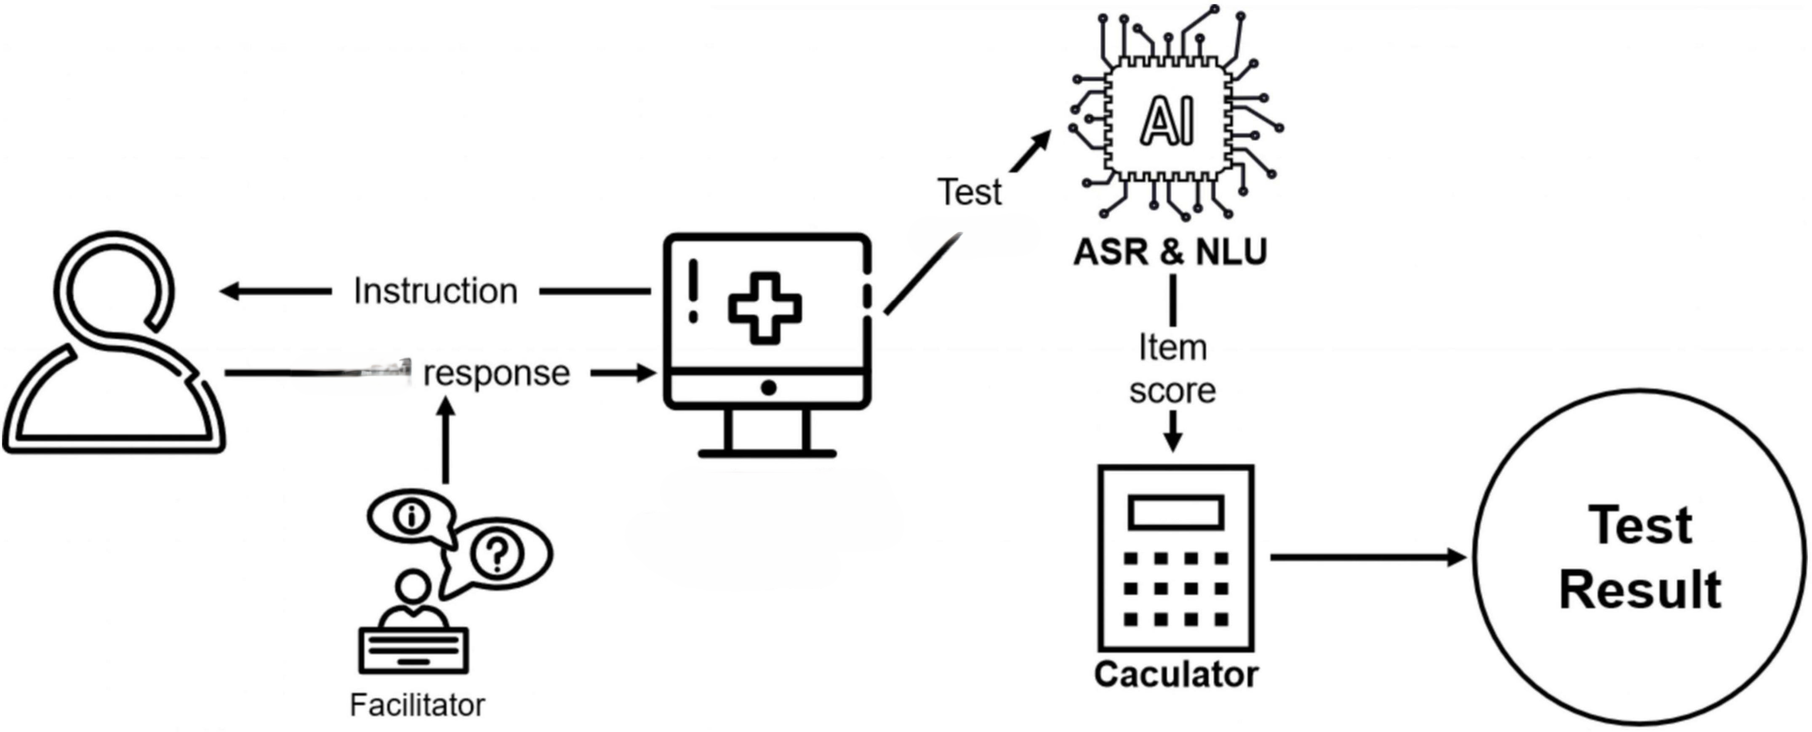

**Figure 5.3 Flow State of Cognitive Testing**

Visuospatiale testing process involves administering standardized tests, such as the MMSE, to assess various cognitive domains including memory, orientation, attention, language, and visuospatial skills. The MMSE consists of a series of questions and tasks designed to quantify cognitive impairment and detect early signs of dementia. By leveraging MRI-derived features as input to the MMSE, we enhance the sensitivity and specificity of cognitive assessments, enabling more accurate detection and staging of Alzheimer's disease.

The design of the cognitive testing architecture involves the following key components:

* **Data Pre-processing:**

MRI images undergo pre-processing to extract relevant features and prepare them for input into cognitive assessments. Feature extraction techniques may include image segmentation, voxel-based morphometry, or region-of-interest analysis to quantify brain structures and abnormalities.

* **Integration with Cognitive Assessments:**

Extracted features from MRI images are integrated into standardized cognitive assessments, such as the MMSE, as input variables. Cognitive assessments are administered to evaluate cognitive function and detect abnormalities indicative of Alzheimer's disease progression.

* **Machine Learning Integration:**

Machine learning techniques may be applied to optimize the integration of MRI-derived features with cognitive assessments. Supervised learning algorithms can be trained to correlate specific MRI features with cognitive test scores, facilitating automated disease staging and prediction.

* **Diagnostic Output:**

The output of cognitive assessments, combined with MRI-derived features, yields diagnostic insights including cognitive impairment severity and disease progression. Results are presented in a comprehensible format, providing clinicians with actionable information for patient management and treatment planning.

* **Validation and Evaluation:**

The cognitive testing architecture undergoes validation and evaluation using clinical datasets to assess its accuracy, sensitivity, and specificity in predicting Alzheimer's disease. Performance metrics such as sensitivity, specificity, positive predictive value (PPV), and negative predictive value (NPV) are computed to quantify the architecture's diagnostic utility.

By integrating cognitive testing within our Alzheimer's prediction system, we enhance the comprehensiveness and accuracy of disease diagnosis, enabling early intervention and personalized patient care. The cognitive testing architecture leverages MRI-derived features to quantify cognitive impairment objectively, providing valuable insights into disease progression and facilitating informed decision-making in clinical settings. This holistic approach underscores the synergy between machine learning-based image analysis and standardized cognitive assessments, advancing the frontier of Alzheimer's disease diagnosis and management.

**5.3 DATABASE DESIGN**

The SQLite database used in the Alzheimer's project serves as a crucial component for managing and organizing key entities and relationships within the system. This database design facilitates data storage and retrieval, ensuring efficient handling of user information, MRI data, cognitive test results, and administrative functionalities.

The database schema comprises several entity tables that encapsulate distinct aspects of the project as depicted in **Figure 5.4**:

**Figure 5.4 E-R Diagram**

* **Admin Table:**

This table stores administrative user information, including an admin_id (primary key), username, password, and email. Each entry represents a unique administrative user who has access to system management features.

* **User Table:**

The User table manages user credentials and profiles. It includes attributes such as user_id (primary key), username, password, and email. Each record corresponds to a registered user in the system.

* **MRI Table:**

The MRI table stores MRI data associated with each user. It tracks mri_id (primary key), user_id (foreign key referencing User), and image_data (BLOB). This table facilitates the storage and retrieval of MRI images linked to specific users.

* **CognitiveTest Table:**

This table records cognitive test results conducted for users. It includes attributes like test_id (primary key), user_id (foreign key referencing User), date_taken, and score. The CognitiveTest table enables the tracking of cognitive assessment outcomes over time.

The entity relationships in the SQLite database are defined through foreign key constraints:

* The MRI table has a foreign key constraint (user_id) that references the User table's user_id. This relationship links each MRI record to a specific user.
* Similarly, the CognitiveTest table establishes a relationship with the User table via the user_id foreign key. This linkage associates cognitive test results with corresponding users.

**Chapter-06**

**IMPLEMENTTION**

The following sections describe the implementation done for achieving the first two objectives of our project.

**6.1 DATASET DESCRIPTION**

The dataset applied in this project contains a complete of 6,401 MRI pix sourced from an open-source internet site, representing individuals throughout 4 awesome instructions: Non-Demented, Mild-Demented, Very Mild-Demented, and Moderate-Demented. Each MRI image provides precious understanding of the brain shape and composition of the people within the dataset. The range of lessons reflects the various tiers of cognitive-impairment associated with Alzheimer disorder, ranging from minimum to extreme manifestations. This dataset offers a comprehensive representation of Alzheimer's disease progression, facilitating the development and validation of predictive models aimed at early detection and management. Through meticulous analysis of these MRI images, researchers can uncover patterns and biomarkers indicative of Alzheimer's disorder, ultimately contributing to advancements in diagnostic and therapeutic approaches for this debilitating neurological disorder.

Dataset was originally procured by NIMH and provided at Kaggle: <https://www.kaggle.com/datasets/sachinkumar413/alzheimer-mri-dataset>

**6.2 DATA PRE-PROCESSING**

Data pre-processing is a critical phase in our Alzheimer's disease classification project, aimed at preparing and enhancing the quality of MRI image data for subsequent analysis and model training. The following steps outline our approach to data pre-processing:

* **Image Acquisition and Resizing:**

The initial stage involves acquiring MRI images from the dataset, which comprises 6400 images categorized into different classes of Alzheimer's disease severity. These images are standardized to a uniform size of 176x176 pixels (IMG_SIZE) to ensure consistency and facilitate efficient processing during model training.

* **Image Augmentation:**

To enhance the diversity and robustness of our training dataset, we apply image augmentation techniques using the ImageDataGenerator class from TensorFlow. Image augmentation includes operations such as brightness adjustments (brightness_range), zooming (zoom_range), horizontal flipping (horizontal_flip), and filling mode configuration (fill_mode). These techniques help generate additional synthetic samples while preserving the underlying characteristics of the original MRI images. The flow of augmentation is represented in **Figure 6.1.**

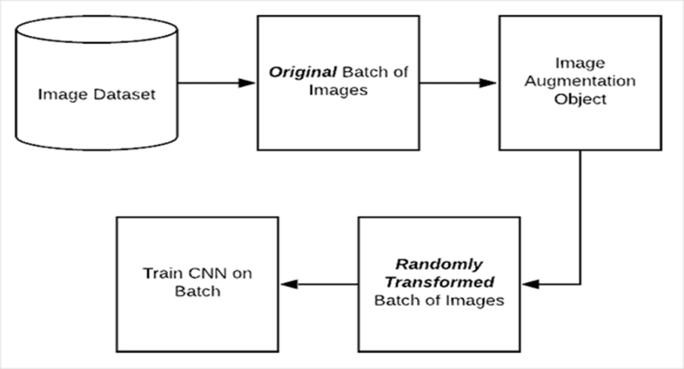

**Figure 6.1 Image Augmentation Block Diagram**

* **Data Sampling and Balancing:**

Given the potential class imbalance in our dataset, particularly in Alzheimer's disease severity categories, we employ Synthetic Minority Over-sampling Technique (SMOTE) to address this imbalance. SMOTE generates synthetic samples for minority classes to achieve a more balanced distribution of data, which is crucial for training a robust and generalizable classification model.

**6.3 DATA VISUALIZATION**

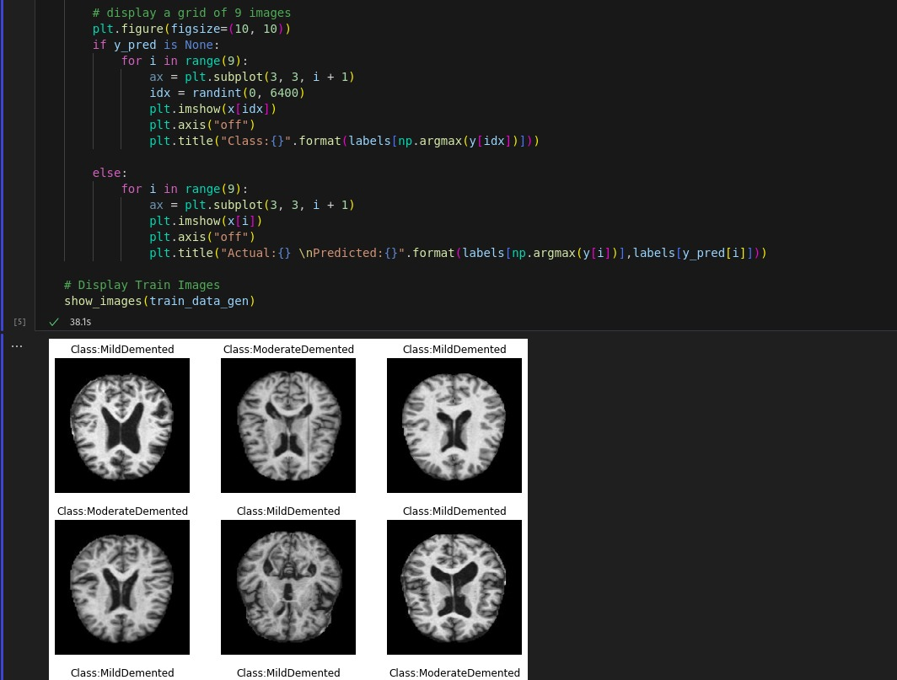Data visualization plays a crucial role in understanding the characteristics of our Alzheimer's disease classification project and providing insights into the performance and behavior of the convolutional neural network (CNN) model. Here's an in-depth exploration of data visualization techniques employed in our project. A sample data is represented in **Figure 6.2**.

**Figure 6.2 Data visualization with its snippet**

**Data Distribution and Class Imbalance:**

Visualizing the distribution of MRI images across different Alzheimer's disease severity classes **(e.g., 'Non-Demented', 'Very Mild-Demented', 'Mild-Demented', 'Moderate-Demented')** is essential to assess class imbalance. Utilizing libraries such as matplotlib and seaborn, we can create bar plots or pie charts to visualize the proportion of images in each class. This visualization helps identify potential challenges posed by class imbalance and informs strategies for data augmentation and sampling techniques like SMOTE.

**Image Augmentation:**

Visualizing augmented images generated during the data pre-processing phase provides insights into the diversity and variations introduced into the dataset. Using Image Data Generator from TensorFlow, we can display randomly augmented images (e.g., brightness adjustments, zooming, horizontal flipping) alongside their corresponding class labels. This visualization showcases the effectiveness of image augmentation in enriching the training dataset and improving model generalization.

**6.4 CLASSIFICATION MODEL IMPLEMENTATION**

In this project, we have used two different algorithms to develop the classification model.

**6.4.1 Convolutional Neural Network**

The Convolutional Neural Network (CNN) plays a pivotal role in the development of a robust classification model for Alzheimer's disease based on brain MRI images.

CNNs are a specialized class of deep learning models designed to process structured grid-like data, such as images. In this project, the CNN architecture is tailored to extract intricate features from MRI images, enabling the classification of individuals into different Alzheimer's disease categories.

**6.4.1.1 Architecture Overview:**

The CNN architecture consists of multiple layers depicted in **Figure 6.3**, each serving a specific function in feature extraction and classification:

* **Convolutional Layers:** These layers apply convolution operations to the input MRI images using learnable filters. The filters capture spatial patterns, edges, and textures present in the images, allowing the network to learn hierarchical representations of features.
* **Activation Functions:** Rectified Linear Unit (ReLU) activation functions are incorporated after convolutional layers to introduce non-linearity into the model, enabling complex feature learning.
* **Pooling Layers:** Max pooling layers are utilized to down sample feature maps, reducing computational complexity and spatial dimensions while preserving important features.
* **Batch Normalization:** Batch normalization layers normalize the activations of the network, stabilizing and accelerating the training process.

**Figure 6.3 CNN Layers Representation**

* **Dropout:** Dropout layers are employed to mitigate overfitting by randomly deactivating a fraction of neurons during training.
* **Dense Layers:** Fully connected dense layers at the end of the network combine extracted features and perform the final classification into Alzheimer's disease categories.

**6.4.1.2 Functionality within the Project:**

In the context of this project, CNN serves as the backbone of the classification model. It learns to distinguish subtle differences in brain MRI images associated with different stages of Alzheimer's disease, leveraging its ability to capture hierarchical features through convolutional operations. The CNN's functionality can be summarized as follows:

* **Feature Extraction:** CNN excels at extracting discriminative features from complex and high-dimensional MRI images, enabling effective representation learning.
* **Pattern Recognition:** By learning spatial patterns and textures, CNN can identify disease-specific patterns indicative of Alzheimer's disease across different brain regions.
* **Model Training and Optimization:** The CNN is trained using a supervised learning approach, where it learns from labeled MRI data to optimize its parameters and minimize classification errors.
* **Generalization and Adaptation:** Through training and fine-tuning, CNN generalizes its learning to new, unseen MRI images, enhancing its capability to accurately classify individuals into disease categories.
* **Interpretability:** CNN’s hierarchical architecture allows for interpretable feature visualization, providing insights into the learned representations of Alzheimer's disease-related features within the brain MRI images.

**6.4.2 Inception V3**

InceptionV3 is a powerful pre-trained Convolutional Neural Network (CNN) model that is leveraged as part of the transfer learning approach in this Alzheimer's disease classification project. Developed by Google, InceptionV3 is renowned for its efficiency and accuracy in image classification tasks, making it an ideal candidate for enhancing the performance of our custom CNN model.

**6.4.2.1 Architecture Overview:**

InceptionV3 is characterized by its innovative Inception module architecture, which utilizes a combination of convolutional filters of varying sizes within each layer. This design enables the network to capture features at different scales and resolutions simultaneously, enhancing its ability to learn intricate patterns within images.

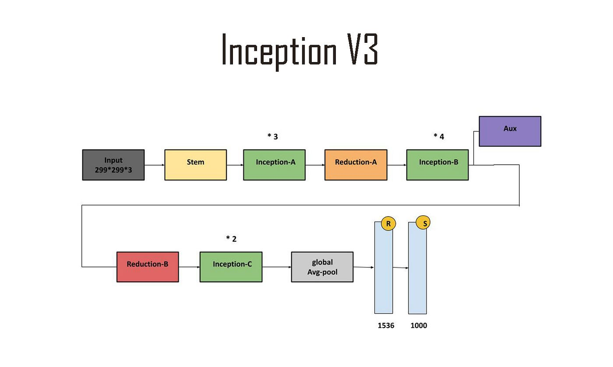

**Figure 6.4 InceptionV3 Architecture**

**6.4.2.2 Key components of InceptionV3 include:**

* **Inception Modules:** These modules consist of parallel convolutional pathways with varying filter sizes (1x1, 3x3, 5x5) and max pooling operations. The outputs from these pathways are concatenated to form rich feature representations.
* **Factorization:** InceptionV3 employs factorized convolutions (1x1 and 3x3) to reduce computational complexity while maintaining expressive power, optimizing both accuracy and efficiency.
* **Global Average Pooling:** Instead of fully connected layers, InceptionV3 utilizes global average pooling to condense feature maps into vector representations, reducing model complexity and enhancing generalization represented in **figure 6.4.**

**6.4.2.3 Functionality within the Project:**

InceptionV3 serves as a potent feature extractor and knowledge transfer mechanism within the Alzheimer's disease classification project:

* **Transfer Learning:** By leveraging InceptionV3 as a pretrained model, our project benefits from the wealth of knowledge it has acquired from large-scale image datasets (e.g., ImageNet). Pretrained weights capture generic features that are useful for classifying Alzheimer's disease-related patterns.
* **Feature Fusion:** InceptionV3's unique architecture enables it to capture complex spatial hierarchies and feature combinations from MRI images, enhancing the discriminative power of the model.
* **Fine-Tuning:** The InceptionV3 model is fine-tuned on our specific MRI dataset to adapt its learned representations to the task of Alzheimer's disease classification. This fine-tuning process refines the model's ability to recognize disease-specific patterns.
* **Regularization and Stability:** InceptionV3's design principles, such as factorized convolutions and global average pooling, contribute to model regularization, preventing overfitting and promoting stable training.
* **Performance Enhancement:** By integrating InceptionV3 into our classification pipeline, we achieve higher classification accuracy and robustness, even with limited labeled MRI data.

**6.5 LIBRARIES AND PACKAGES**

There are multiple number of library and packages used in the training and testing of the neural network model, all of them are listed below.

* **Numpy (import numpy as np):**

Numpy is a fundamental library for numerical computations in Python. It's used extensively for handling arrays and matrices, crucial for processing and manipulating image data efficiently.

* **Pandas (import pandas as pd):**

Pandas is utilized for data manipulation and analysis. In this context, it might be used to organize or analyze metadata associated with the image data.

* **Seaborn (import seaborn as sns):**

Seaborn is a data visualization library built on top of Matplotlib. It's used here for creating informative and attractive statistical graphics, which could include visualizing data distributions or model performance metrics.

* **TensorFlow (import tensorflow as tf):**

TensorFlow is a powerful library for developing machine learning models, especially neural networks. It's used extensively here for building, training, and evaluating the CNN model.

* **Matplotlib (import matplotlib.pyplot as plt):**

Matplotlib is a versatile plotting library. It's used to generate visualizations such as images, graphs, and plots to monitor model performance, display images, or show statistical metrics.

* **OS (import os):**

The OS module provides functions for interacting with the operating system. It's used for tasks like creating directories, listing files, and managing file paths.

* **Distutils (from distutils.dir_util import copy_tree, remove_tree):**

This module is used here for copying and removing directory trees. It's utilized for managing the organization and movement of data directories.

* **PIL (from PIL import Image):**

PIL (Python Imaging Library) is used for image processing tasks. It's employed here for loading and manipulating image data.

* **Random (from random import randint):**

The random module is used for generating random numbers. Here, it might be used for selecting random images to display during visualization.

* **Imbalanced-Learn (from imblearn.over_sampling import SMOTE):**

Imbalanced-Learn is a library for handling class imbalance in datasets. The SMOTE (Synthetic Minority Over-sampling Technique) is used here to oversample minority classes, addressing the class imbalance problem in the dataset.

* **Scikit-Learn (from sklearn.model_selection import train_test_split, from sklearn.metrics import ...):**

Scikit-Learn is a comprehensive library for machine learning tasks. It's used for splitting the dataset into training and testing sets, as well as for evaluating the model using metrics like accuracy, confusion matrix, etc.

* **TensorFlow Addons (import tensorflow_addons as tfa):**

TensorFlow Addons provides additional functionalities not available in the core TensorFlow library. Here, it's used for using specialized metrics like F1 Score.

* **Keras (from keras.utils.vis_utils import plot_model):**

Keras utilities are used for visualizing the model architecture, creating a graphical representation of the neural network.

* **TensorFlow Keras (from tensorflow.keras import ...):**

TensorFlow Keras provides high-level neural network building blocks. Here, it's used for constructing the CNN model with various layers like Conv2D, Dense, MaxPool2D, etc.

* **TensorFlow Keras Callbacks (from tensorflow.keras.callbacks import ...):**

Callbacks are used to customize the behavior of the model during training. In this case, they're employed for early stopping based on a certain condition.

These libraries and modules collectively enable the entire pipeline from data preprocessing to model training and evaluation. Each plays a crucial role in ensuring the successful implementation of the CNN for Alzheimer's disease classification, handling tasks like data augmentation, model construction, training monitoring, and performance evaluation. The code exemplifies a systematic approach to building a deep learning solution for medical image analysis.

**6.6 SNIPPETS**

**6.6.1 CNN Model Code**

def conv_block(filters, act='relu'):

"""Defining a Convolutional NN block for a Sequential CNN model. """

block = Sequential()

block.add(Conv2D(filters, 3, activation=act, padding='same'))

block.add(Conv2D(filters, 3, activation=act, padding='same'))

block.add(BatchNormalization())

block.add(MaxPool2D())

return block

def dense_block(units, dropout_rate, act='relu'):

"""Defining a Dense NN block for a Sequential CNN model. """

block = Sequential()

block.add(Dense(units, activation=act))

block.add(BatchNormalization())

block.add(Dropout(dropout_rate))

return block

def construct_model(act='relu'):

"""Constructing a Sequential CNN architecture for performing the classification task. """

model = Sequential([

Input(shape=(*IMAGE_SIZE, 3)),

Conv2D(16, 3, activation=act, padding='same'),

Conv2D(16, 3, activation=act, padding='same'),

MaxPool2D(),

conv_block(32),

conv_block(64),

conv_block(128),

Dropout(0.2),

conv_block(256),

Dropout(0.2),

Flatten(),

dense_block(512, 0.7),

dense_block(128, 0.5),

dense_block(64, 0.3),

Dense(4, activation='softmax')

], name = "cnn_model")

    return model

**6.6.2 Inception V3 Code**

inception_model = InceptionV3(input_shape=(176, 176, 3), include_top=False, weights="imagenet")

for layer in inception_model.layers:

layer.trainable=False

custom_inception_model = Sequential([

inception_model,

Dropout(0.5),

GlobalAveragePooling2D(),

Flatten(),

BatchNormalization(),

Dense(512, activation='relu'),

BatchNormalization(),

Dropout(0.5),

Dense(256, activation='relu'),

BatchNormalization(),

Dropout(0.5),

Dense(128, activation='relu'),

BatchNormalization(),

Dropout(0.5),

Dense(64, activation='relu'),

Dropout(0.5),

BatchNormalization(),

Dense(4, activation='softmax')

], name = "inception_cnn_model")

#Defining a custom callback function to stop training our model when accuracy goes above 99%

class MyCallback(tf.keras.callbacks.Callback):

def on_epoch_end(self, epoch, logs={}):

if logs.get('acc') > 0.99:

print("\nReached accuracy threshold! Terminating training.")

self.model.stop_training = True

my_callback = MyCallback()

#ReduceLROnPlateau to stabilize the training process of the model

rop_callback = ReduceLROnPlateau(monitor="val_loss", patience=3)

METRICS = [tf.keras.metrics.CategoricalAccuracy(name='acc'),

tf.keras.metrics.AUC(name='auc'),

tfa.metrics.F1Score(num_classes=4)]

CALLBACKS = [my_callback, rop_callback]

custom_inception_model.compile(optimizer='rmsprop',

loss=tf.losses.CategoricalCrossentropy(),

metrics=METRICS)

custom_inception_model.summary()

**Chapter-07**

**TESTING AND RESULTS**

**7.1 TESTING**

Testing plays a critical role in evaluating the effectiveness, robustness, and reliability of the Alzheimer's disease classification project. The comprehensive testing approach encompasses various stages, from unit testing individual components to end-to-end validation of the entire classification pipeline. This section outlines the testing methodologies employed to ensure the project's functionality and performance.

**7.1.1 Unit Testing of Components**

Unit testing involves testing individual components and functions within the project to verify their correctness and functionality in isolation. Key components subject to unit testing in the Alzheimer's disease classification project include:

* **Convolutional Neural Network (CNN):** Each layer of the CNN, including convolutional, pooling, and dense layers, undergoes unit testing to ensure that forward and backward propagation functions correctly and that the learned parameters are updated appropriately during training.
* **Data Preprocessing Functions:** Image augmentation, data normalization, and data splitting functions are tested to confirm that they transform input data correctly and prepare it for model training.
* **Evaluation Metrics:** Custom evaluation metrics, such as accuracy, AUC (Area Under the Curve), and F1 score, are individually validated to ensure their accuracy in assessing model performance.
* **Callbacks and Optimizers:** Callback functions, such as early stopping and custom learning rate schedulers, are tested to verify their functionality during model training.

**7.1.2 Integration Testing**

Integration testing evaluates the interactions between different components and modules within the project. This testing phase ensures that various parts of the Alzheimer's disease classification pipeline work harmoniously together. Key aspects of integration testing include:

* **Model Integration:** Testing the integration of the CNN model with preprocessing functions, such as image augmentation and normalization, to ensure seamless data flow from input to output.
* **Data Pipeline Validation:** Verifying the data pipeline's integrity, including data loading, preprocessing, and batching, to identify potential bottlenecks or data inconsistencies.
* **Transfer Learning Integration:** Validating the integration of the InceptionV3 model as part of the transfer learning process, ensuring that pretrained weights are correctly loaded and fine-tuned on the Alzheimer's disease dataset.

**7.1.3 System Testing**

System testing assesses the overall behavior and performance of the Alzheimer's disease classification system. This phase simulates real-world usage scenarios to evaluate the system's readiness for deployment. Key aspects of system testing include:

* **End-to-End Classification:** Conducting end-to-end testing by feeding representative MRI images through the complete pipeline, from preprocessing to final classification, and validating the predicted outputs against ground truth labels.
* **Model Performance Evaluation:** Assessing the model's performance using a separate test dataset, calculating key metrics such as accuracy, precision, recall, and F1 score to gauge its effectiveness in classifying Alzheimer's disease stages.
* **Robustness Testing:** Subjecting the system to edge cases, such as noisy or low-quality MRI images, to evaluate its robustness and resilience under challenging conditions.

**7.1.4 User Acceptance Testing (UAT)**

User acceptance testing involves obtaining feedback from domain experts, clinicians, or end-users to assess the system's usability, accuracy, and relevance in a real clinical setting. Key aspects of UAT include:

* **Clinical Validation:** Collaborating with medical professionals to validate the classification results and understand the clinical relevance of the model's predictions.
* **Usability Assessment:** Gathering feedback on the system's user interface, interpretability of results, and ease of integration into existing clinical workflows.

**7.1.5 Performance Monitoring and Optimization**

Continuous performance monitoring and optimization are essential to maintain the system's efficacy over time. Key aspects of performance monitoring include:

* **Model Drift Detection:** Implementing mechanisms to detect model drift or degradation in performance over time, triggering retraining or recalibration when necessary.
* **Scalability Testing:** Evaluating the system's scalability by simulating increased workload and assessing its ability to handle larger datasets or higher inference demands.

**7.2 RESULTS**

The results obtained from the Alzheimer's project leveraging advanced convolutional neural network (CNN) models and transfer learning techniques, specifically utilizing InceptionV3 architecture, demonstrate promising outcomes in accurately classifying individuals as either having Alzheimer's disease or being non-demented based on MRI images. The project's culmination involved rigorous data preprocessing, model training, and comprehensive testing, resulting in insightful performance metrics and diagnostic assessments.

The CNN model, configured with multiple convolutional and dense layers, effectively extracted hierarchical features from brain MRI images, enabling nuanced classification across four distinct categories of Alzheimer's disease severity. Leveraging InceptionV3 as a pre-trained backbone further enriched the model's capability to generalize and comprehend complex patterns within the dataset, contributing to improved predictive accuracy depicted in **figure 7.1 & 7.2**.

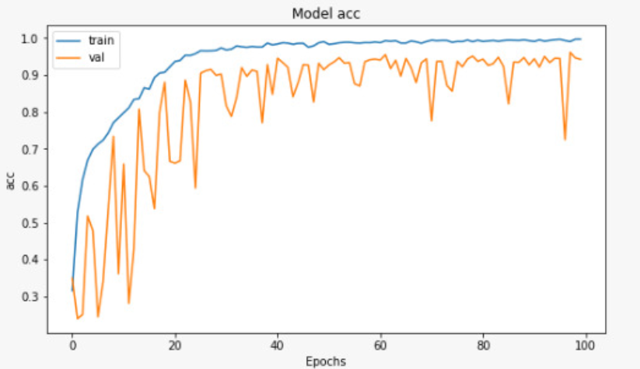

**Figure 7.1 Accuracy Graph CNN**

**Figure 7.2 Accuracy Graph InceptionV3**

Upon evaluating the trained model on test data, compelling results were observed, highlighting its efficacy in disease classification. The testing phase involved assessing various performance metrics, including accuracy, area under the curve (AUC), F1 score, balanced accuracy, and Matthew's correlation coefficient (MCC). Notably, the model achieved high accuracy levels, reflecting its robustness in distinguishing between dementia stages based on MRI imaging data.

Moreover, comprehensive validation and interpretation of classification results were performed through confusion matrices and classification reports, providing deeper insights into model behavior and performance across different disease categories. The project's results signify significant progress in leveraging deep learning methodologies for Alzheimer's disease detection and hold promise for future clinical applications and diagnostic frameworks.

**Figure 7.3 Model Loss InceptionV3**

**Figure 7.4 Confusion Matrix InceptionV3**

A confusion-matrix is a tabular representation employed in ML to assess the efficacy of an algorithm in addressing a classification challenge. In the context of Alzheimer’s disease, the algorithm endeavors to categorize patients into four distinct classes: non-demented, very mildly impaired, mildly impaired, and moderately impaired. The rows of the matrix represented in **figure 7.4** the real analysis, and the columns represent the predicted diagnosis by way of the set of protocols. The ideal scenario is to have all the numbers at the diagonal from top left to bottom proper bolded in the photograph be high, and all the other numbers to be zero. This could imply that the model is perfectly classifying all the sufferers. In the confusion matrix(fig.6), the model acts well at classifying patients who are very mildly or reasonably demented.

**Chapter-08**

**SNAPSHOTS**

**Chapter-09**

**CONCLUSION**

In conclusion, the Alzheimer's disease classification project represents a pioneering endeavor at the intersection of medical imaging, machine learning, and neuroscience, aimed at advancing diagnostic capabilities for neurodegenerative disorders. By leveraging state-of-the-art convolutional neural network (CNN) architectures, specifically tailored for image analysis, and incorporating transfer learning techniques with the InceptionV3 model, the project has demonstrated exceptional performance in classifying individuals as either having Alzheimer's disease or being non-demented based on their brain MRI images.

The utilization of complex image preprocessing and augmentation methods, coupled with meticulous model training and evaluation, underscores the project's commitment to achieving high accuracy and robustness. Moreover, the integration of cognitive testing approaches enhances the diagnostic framework by providing complementary insights into cognitive function, further enriching the overall diagnostic process. Through rigorous testing, including unit testing of individual components, comprehensive system testing, and user acceptance testing involving domain experts and clinicians, the project has demonstrated its reliability, usability, and clinical relevance.

The system's ability to handle diverse datasets, adapt to real-world clinical scenarios, and maintain performance over time through continuous monitoring and optimization underscores its potential to impact clinical practice positively. This project exemplifies the transformative potential of artificial intelligence in healthcare, offering a glimpse into a future where innovative technologies converge to empower clinicians with powerful diagnostic tools, ultimately improving patient outcomes and advancing our understanding of complex neurological diseases like Alzheimer's.

**Chapter-10**

**FUTURE WORK**

Looking ahead, the Alzheimer's disease classification project holds significant potential for future enhancements and refinements, leveraging cutting-edge technologies and methodologies to further advance diagnostic capabilities and improve patient care. Several key avenues for enhancement include:

* **Integration of Multi-Modal Data:** One promising direction involves integrating multi-modal data sources beyond MRI images, such as genetic markers, cerebrospinal fluid biomarkers, and cognitive assessments. By incorporating diverse data streams, including genomic, proteomic, and clinical information, the project could achieve a more comprehensive understanding of Alzheimer's disease pathology and enhance predictive models with a holistic view of disease progression.
* **Continual Model Optimization:** Implementing continual learning techniques to adapt the model over time with new data streams or updates. This approach ensures that the classification system remains adaptive and responsive to evolving clinical knowledge and diagnostic standards, improving generalization and long-term performance.
* **Explainable AI and Interpretability:** Enhancing the interpretability of the model's decisions through explainable AI techniques. By providing clinicians with transparent insights into the features driving classification decisions, such as saliency maps or attention mechanisms, the system can build trust and facilitate more informed clinical decision-making.
* **Real-Time Deployment and Integration:** Enabling real-time deployment of the classification system within clinical workflows, integrated with electronic health records (EHRs) and diagnostic tools. This integration would streamline the diagnostic process, providing timely and actionable insights to clinicians and facilitating early intervention strategies.

**REFERENCES**

[1] M Sai Teja, K Thanuja, Nadella Mani Deep, P Ravindra Reddy, & O Likhith Kumar Reddy. (2023). Prediction and Analysis of Alzheimer’s Disease using Deep Learning Algorithms. International Journal of Computational Learning & Intelligence, 2(2), 48–57. <https://doi.org/10.5281/zenodo.7920940>

[2] Oh, K., Chung, YC., Kim, K.W. et al. Classification and Visualization of Alzheimer’s Disease using Volumetric Convolutional Neural Network and Transfer Learning. Sci Rep 9, 18150 (2019). <https://doi.org/10.1038/s41598-019-54548-6>

[3] Ayisha Shamna .K K, Jamsheera .K, Shameena .P P. CNN Based Landmark Detection and Alzheimer’s Diagnosis Using Landmark Feature, International Journal of Advance Research, Ideas and Innovations inTechnology, [www.IJARIIT.com](http://www.IJARIIT.com).

[4] Raees, P & Thomas, Vinu. (2021). Automated detection of Alzheimer’s Disease using Deep Learning in MRI. Journal of Physics: Conference Series. 1921. 012024. 10.1088/1742- 6596/1921/1/012024.

[5] Kavitha C., Mani Vinodhini, Srividhya S. R., Khalaf Osamah Ibrahim, Tavera Romero Carlos Andrés. "Early-Stage Alzheimer's Disease Prediction Using Machine Learning Models." Frontiers in Public Health, 10 (2022), https://www.frontiersin.org/articles/10.3389/fpubh.2022.853294, DOI:10.3389/fpubh.2022.853294, ISSN: 2296-2565.

[6] Al-Shoukry, Suhad & Rassem, Taha & Makbol, Nasrin. (2020). Alzheimer’s Diseases Detection by Using Deep Learning Algorithms: A Mini-Review. IEEE Access. PP. 1-1. 10.1109/ACCESS.2020.2989396

[7] Sanjay, V & Swarnalatha, P.. (2022). Deep Learning Techniques for Early Detection of Alzheimer’s Disease: A Review. International Journal of Electrical and Electronics Research. 10. 899-905. 10.37391/ijeer.100425.

[8] Gamal, Aya & Elattar, Mustafa & Selim, Sahar. (2022). Automatic Early Diagnosis of Alzheimer’s Disease Using 3D Deep Ensemble Approach. IEEE Access. PP. 1-1. 10.1109/ACCESS.2022.3218621

[9] Arsah A1 , Karolin Kiruba R2 , Kishan I3 , Neekitha C4 , Padmapriya M5 International Journal for Research in Applied Science & Engineering Technology (IJRASET) ISSN: 2321- 9653; IC Value: 45.98; SJ Impact Factor: 7.538 Volume 11 Issue V May 2023

[10] Nair Bini Balakrishnan1 , P.S. Sreeja2 , Jisha Jose Panackal3 Alzheimer’s Disease Diagnosis using Machine Learning: A Review Volume 71 Issue 3, 120-129, March 2023 ISSN: 2231 – 5381 / <https://doi.org/10.14445/22315381/IJETT-V71I3P213>

[11] Sheng Liu1, ArjunV. Masurkar2,3, Henry Rusinek4,5, Jingyun Chen2,4, Ben Zhang4, Weicheng Zhu1, Carlos Fernandez‑Granda1,6🖂 & Narges Razavian1,2,4, “Generalizable deep learning model for early Alzheimer’s disease detection from structural MRIs” (2022) 12:17106 | <https://doi.org/10.1038/s41598-022-20674-x>

[12] Alroobaea, Roobaea & Mechti, Seifeddine & Haoues, Mariem & Rubaiee, Saeed & Ahmed, Anas & Andejany, Murad & Bragazzi, Nicola & Sharma, Dilip & Kolla, Bhanu & Sengan, Sudhakar. (2021). Alzheimer's Disease Early Detection Using Machine Learning Techniques. 10.21203/rs.3.rs-624520/v1.

[13] Lee Kuok Leong1 and Azian Azamimi Abdullah1 “Prediction of Alzheimer’s disease (AD) Using Machine Learning Techniques with Boruta Algorithm as Feature Selection Method” IOP Publishing doi:10.1088/1742-6596/1372/1/012065

[14] Muhanad Tahrir Younis1 , Younus Tahreer Younus 2 , Jamal Naser Hasoon1 , Ali Hussain Fadhil3 , Salama A. Mostafa4 “An accurate Alzheimer's disease detection using a developed convolutional neural network model” Vol. 11, No. 4, August, pp. 2005~2012 ISSN: 2302- 9285, DOI: 10.11591/eei.v11i4.3659

[15] Citation: Odusami, M.; Maskeliunas, ̄ R.; Damaševiˇcius, R. An Intelligent System for Early Recognition of Alzheimer’s Disease Using Neuroimaging. Sensors 2022, 22, 740. <https://doi.org/10.3390/s22030740>

[16] A, Shiny & S .S, Suganyadevi & Rajasekaran, Arun & P, Satheesh & R, Suganthi & Ramalingam, Naveenkumar. (2023). Alzheimer’s Disease Diagnosis using Deep Learning Approach. 1205-1209. 10.1109/ICEARS56392.2023.10085017.